CS470 Computer Architecture
Exercise on Arithmetic Units, Spring 2017
Discuss March 8, 2017

- In the table below, show how multiplication would proceed, multiplicand is 1110 and multiplier is 1101. Use as many rows as needed. Use the optimized multiplier below.
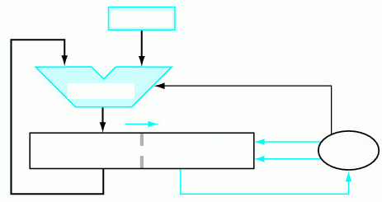

Iteration | Step | Multiplicand | Product Register
0 | Initial values
1
2

- In the figure below on the left, give the values of the Result and CarryOut if a =0, b =1, Less = 0 Ainvert =0 Binvert = 1, CarryIn = 1 and Operation = 10.

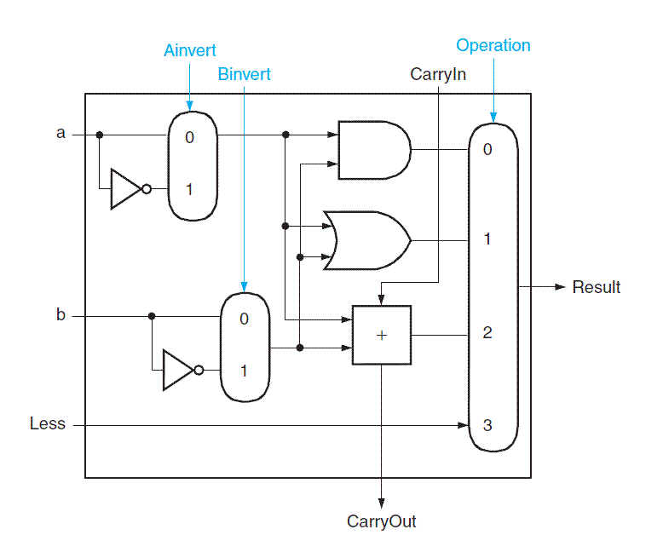 | 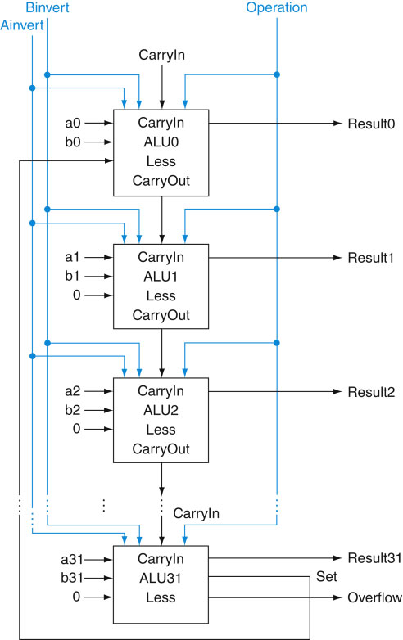

- In the figure on the right, give values on all lines if +3 and -7 are being added. You only need to show the values for the three least significant bits and the most significant bit.

